**CLOUD COMPUTING**

**ASSIGNMENT 1**



**SUBMITTED TO**

SIR WAQAS SALEEM

**SUBMITTED BY**HAMNA MAHMOOD

2023-BSE-025

BSE V-A

**Assignment Repository:** https://github.com/HamnaMahmood20/assignment1

**Website link:** https://hamnamahmood20.github.io/

**Task 1: Run Gitea in Codespace and Create an Initial Repo**  
**Set up Gitea:**

* Run a Gitea server inside your Codespace.
* Use HTTPS for communication (SSH is not supported in Codespace).

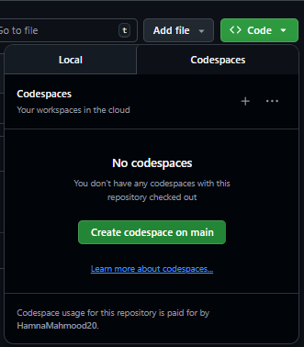

Running this command in terminal bottom in Codespace to start a container named Gitea where Port 3000 will be used for the website.

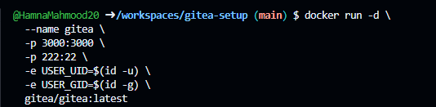

Click globe icon next to port 3000 on the Ports tab. This will take us to login page for Gitea as shown below,

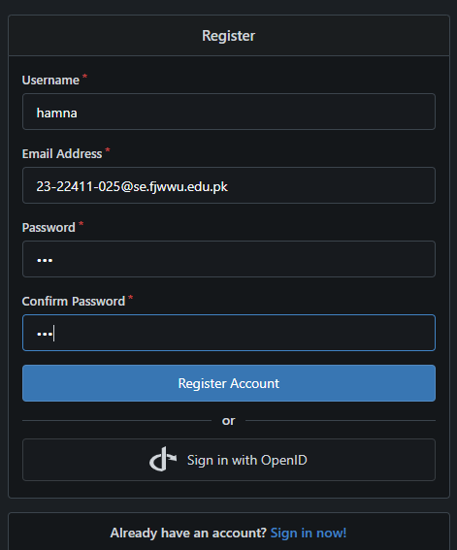

**Create a Repository:**

* Create a new repository on your Gitea server.

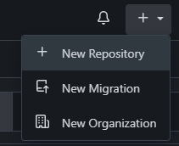

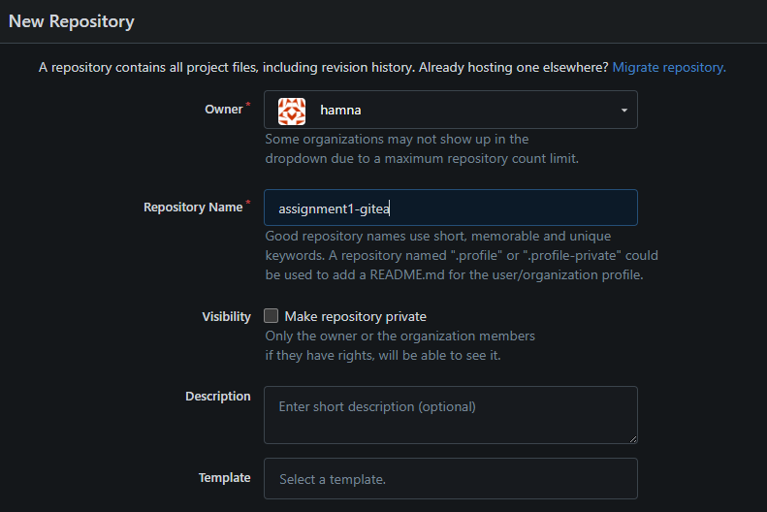

* Add a README.md file listing each student's name and roll number.

Making a directory named ‘assignment1’ in terminal, initializing an empty repository and adding my **name and roll number within.**

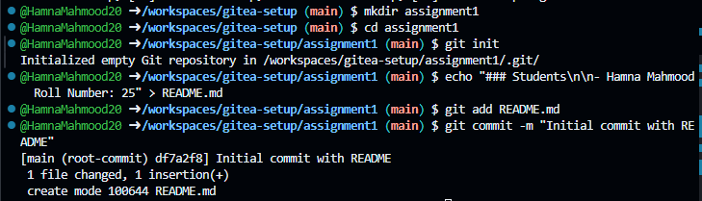

**Add Remote Repo:**

* Use the following command to add your Gitea repository as a remote:  
       git remote add gitea <your_gitea_repo_https_url>



* Push your initial commit containing the README.md to Gitea.

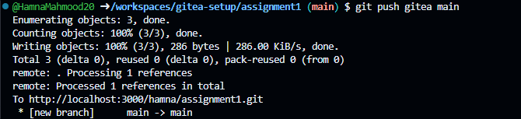



**Task 2: Mirror README.md from Gitea to GitHub**  
**Continue Working with Your Existing Repository:**

* You will use the same repository that you created and pushed to your Gitea server in Task 1.



**Create GitHub Repository:**

* Create a new GitHub repository named assignment 1.

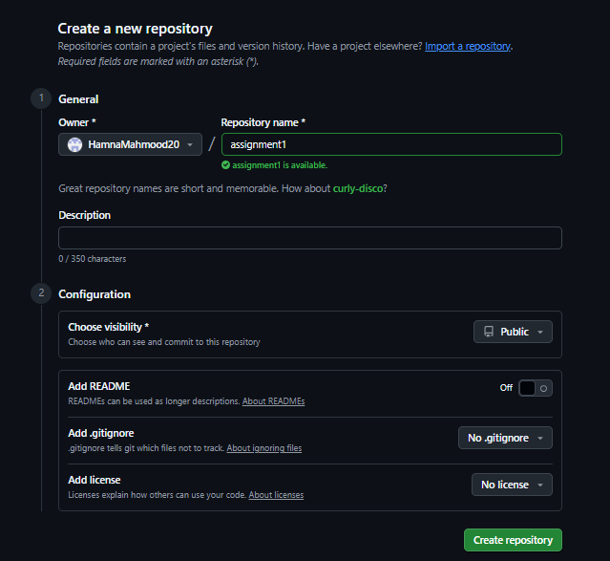

**Add GitHub as a Second Remote:**

* Add your GitHub repository as a remote to your local repository:  
       git remote add github <your_github_repo_https_url>

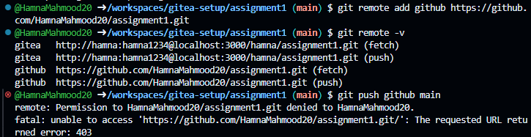

**Generating token** (classic) to resolve 403 Github Authentication error while pushing,

Going to github then to Settings,

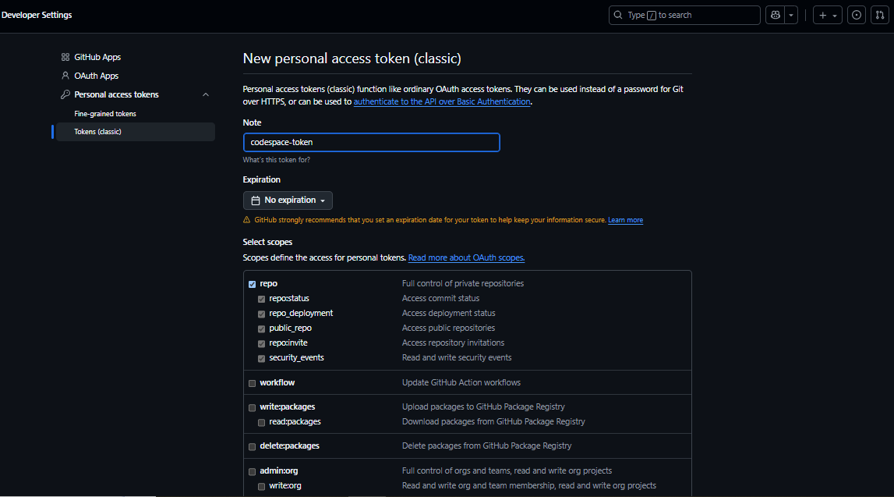

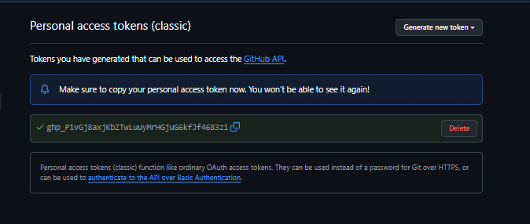

Now, trying the remote command again in terminal,



**Push the README.md File to GitHub:**

* Push the contents (including the README.md) from your local repository to GitHub.

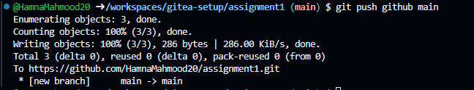

Checking Github in our repository for confirmation,

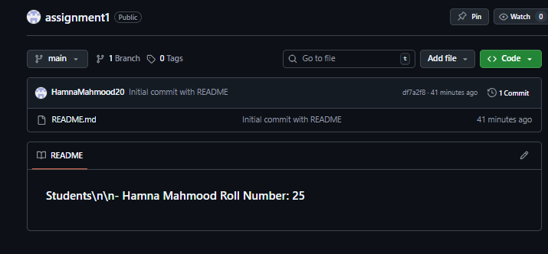

Hence, README.md file ahs been successfully mirrored in Github repository.

**Verify Remotes:**

* Run git remote -v and ensure both remotes (gitea and github) are listed.

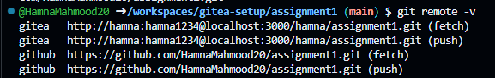

**Task 3: Use Git LFS for Large Files**  
  
**Install Git LFS:**

* Set up Git LFS in your local repository.



**Add Large Files:**

* Add three files larger than 100 MB each to your repository.  
  
* Track them using Git LFS:  
       git lfs track "*.ext"  
   
* Replace .ext with the appropriate file extension.



**Reference in Assignment Repo:**

* Commit and push these large files to your GitHub assignment 1 repo.  
   

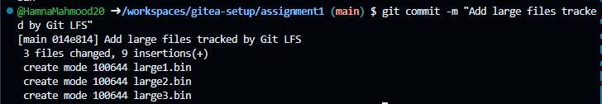

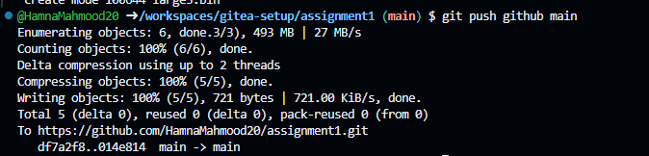

* Ensure the files are referenced correctly in your repository history.

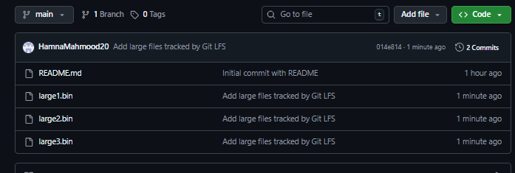

**Task 4: Create a Portfolio/CV with GitHub Pages**  
  
**Create a new repository for GitHub Pages:**

* Create a new repository named <your-username>.github.io.  
   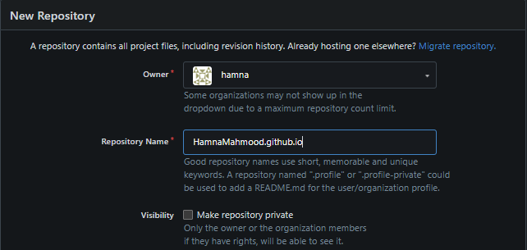
* Replace <your-username> with your actual GitHub username (e.g., johnsmith.github.io).

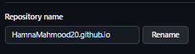

**Design Your Portfolio/CV:**

* Create your portfolio or CV in HTML/CSS (or use a static site generator).

index.html

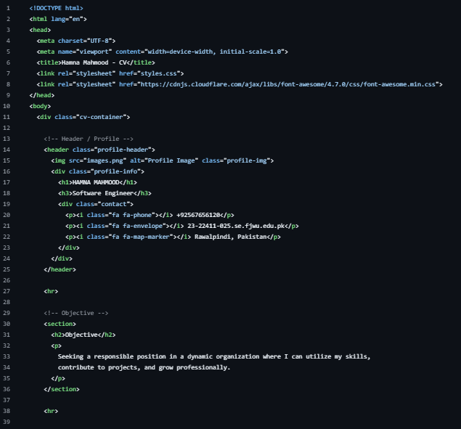

styles.css

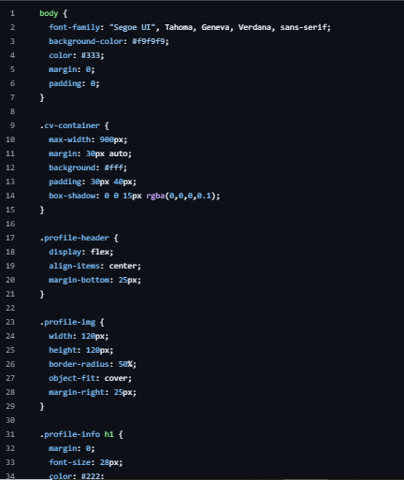

**Publish with GitHub Pages:**

* Push your portfolio/CV files to the <your-username>.github.io repository.

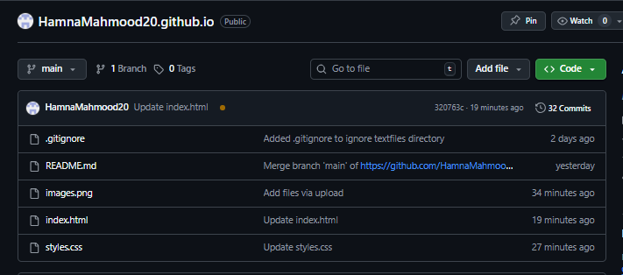

* Enable GitHub Pages in your repository settings if not automatically enabled.

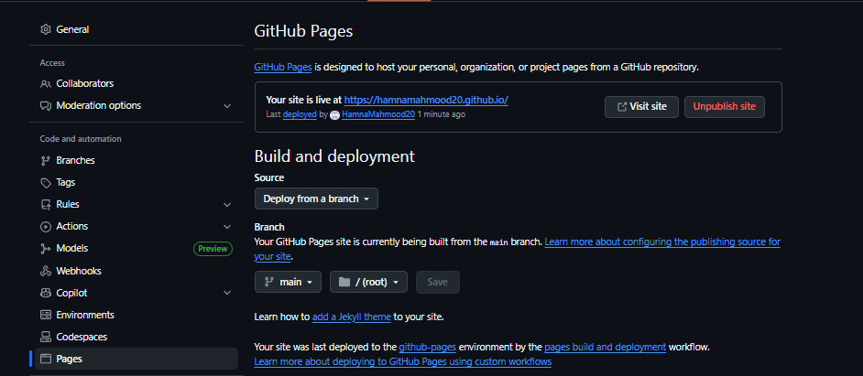

* Publish your site and share the link.

My website is at: https://hamnamahmood20.github.io/

